Trusted Sports Alliance
KS2 Sports Hall Athletics
Girls / Boys Team Sheet
 | 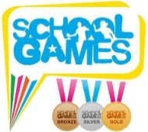 |  |  |  | Field Event |  |  |  |  | Relay Events
 |  | 1 lap | 2 lap | 6 lapPaarlauf | Speed Bounce | Stand Long Jump | Chest Push | Vertical Jump | Indoor javelin | 4x1 Lap | 4 x 2 Lap
Number of athletes per event |  | 2 (A&B) | 2 (A&B) | 2 | 2 | 2 | 2 | 2 | 2 | 4 | 4
1
2
3
4
5
6
7
8
9
School Name:

